SONAR Analysis in Jenkins.

Download:

Sonar Qube: <https://www.sonarqube.org/downloads/>

Sonar Scanner:

<https://docs.sonarqube.org/display/SCAN/Analyzing+with+SonarQube+Scanner>

|  |
| --- |
| **Enviornement Variables:** |

Start the Sonar Server:

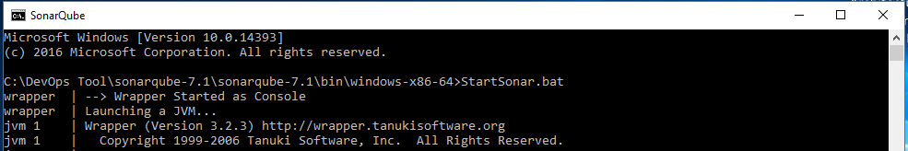

Sonar Qube:

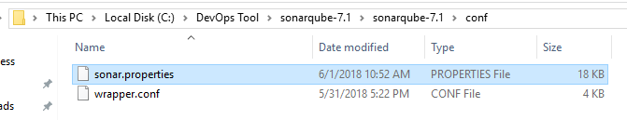

**You Can edit sonar.Properties or make entry in the Jenkins sonarqube runner**

sonar.projectKey=myaws

# this is the name and version displayed in the SonarQube UI. Was mandatory prior to SonarQube 6.1.

sonar.projectName=oncloud

sonar.projectVersion=1.0

# This property is optional if sonar.modules is set.

sonar.sources=.

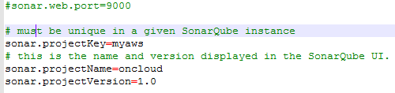

Jenkins -- Manage Jenkisn – Plugin Manager

Go to avaialble and under searh enter sonarqube and download.Once download you will find it under Installed.

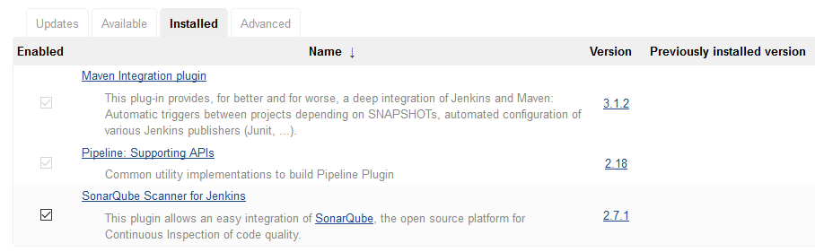

Jenkins -- Manage Jenkisn – Global Tool Configuration

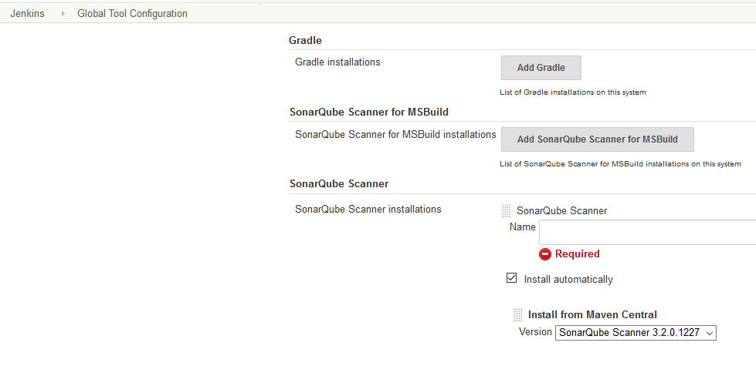

Jenkins -- Manage Jenkisn – Configure System

Here server authentication is myaws

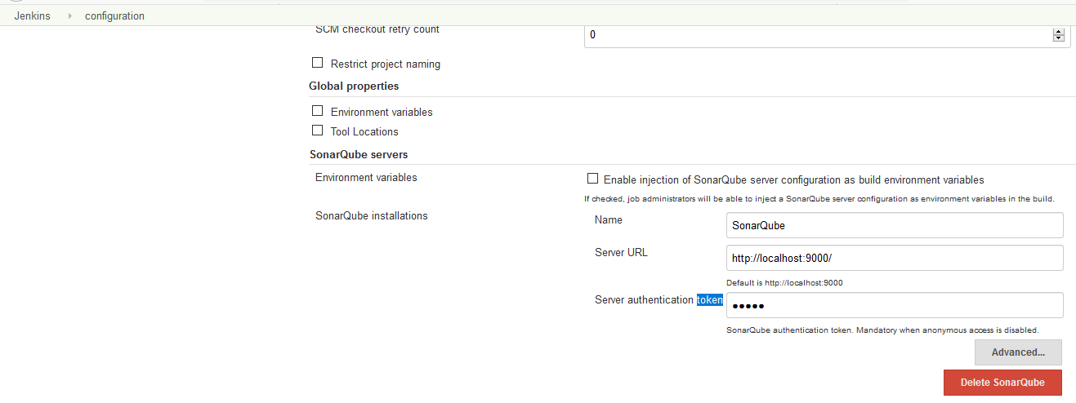

Add a Build/Pre Step:

Command:scan

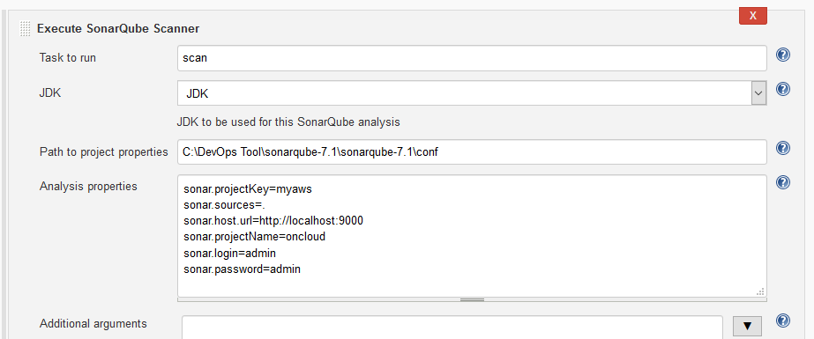

Successful Logs:

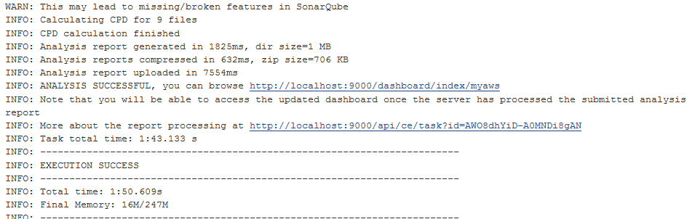

In Dash Board:

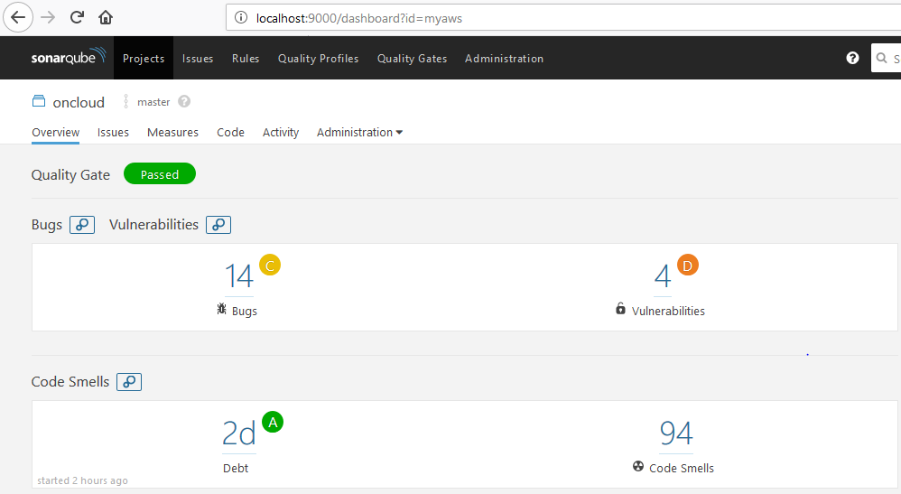

DEBUG

Incorrect Configuration:

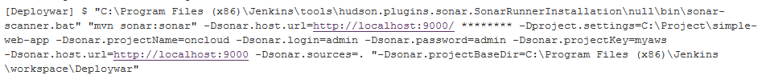

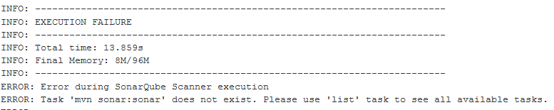

Resolution: Changed the command to sonar

And Path to project properties to C:\DevOps Tool\sonarqube-7.1\sonarqube-7.1\conf

Additional on a Standalone Sonar Qube Scanner

[Analyzing with SonarQube Scanner](https://docs.sonarqube.org/display/SCAN/Analyzing+with+SonarQube+Scanner)

URL: <https://docs.sonarqube.org/display/SCAN/Analyzing+with+SonarQube+Scanner>

Download preferably Latest Version corresponding to the OS.

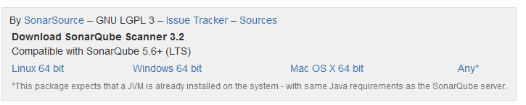

Validate the Installation using below command.

